Tendermint Report

**5th July 2019**

## SYSTEM SPECIFICATION

|  |  |
| --- | --- |
| OS: Ubuntu 18.04 bionic | Kernel: x86_64 Linux 4.15.0-51-generic |
| Shell: bash 4.4.19 | CPU: Intel Xeon E5-1620 v2 @ 8x 3.9GHz [34.0°C] |
| GPU: Quadro K2000 | RAM: 6306MiB / 128814MiB |

# THROUGHPUT DATA *[Varying Transaction Size]*

1. **Transaction/Sec Vs Node** : Small Transaction Size ( <=250 bytes) || Rest parameter - [ *Rate of transection : 1000 txn/sec Time duration : 50 sec* ]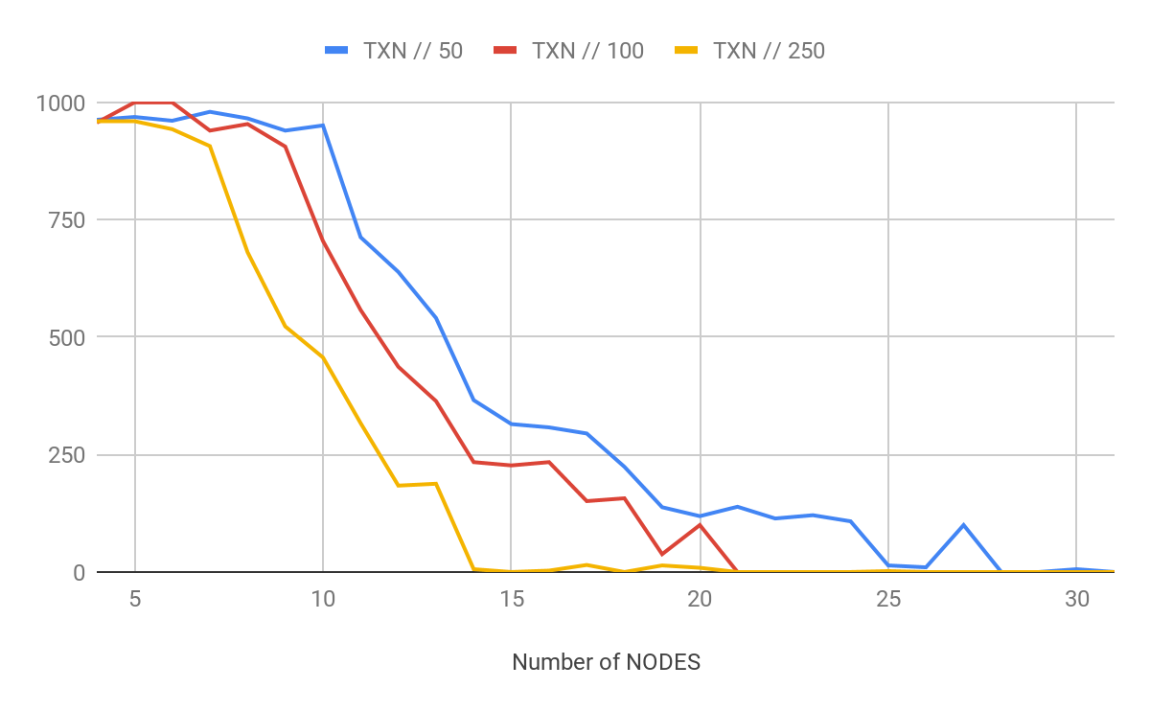
2. **BLOCKS/SEC VS NODE : Small Transaction Size ( <=250 bytes) || Rest parameter - [** *Rate of transection : 1000 txn/sec Time duration : 50 sec* **]**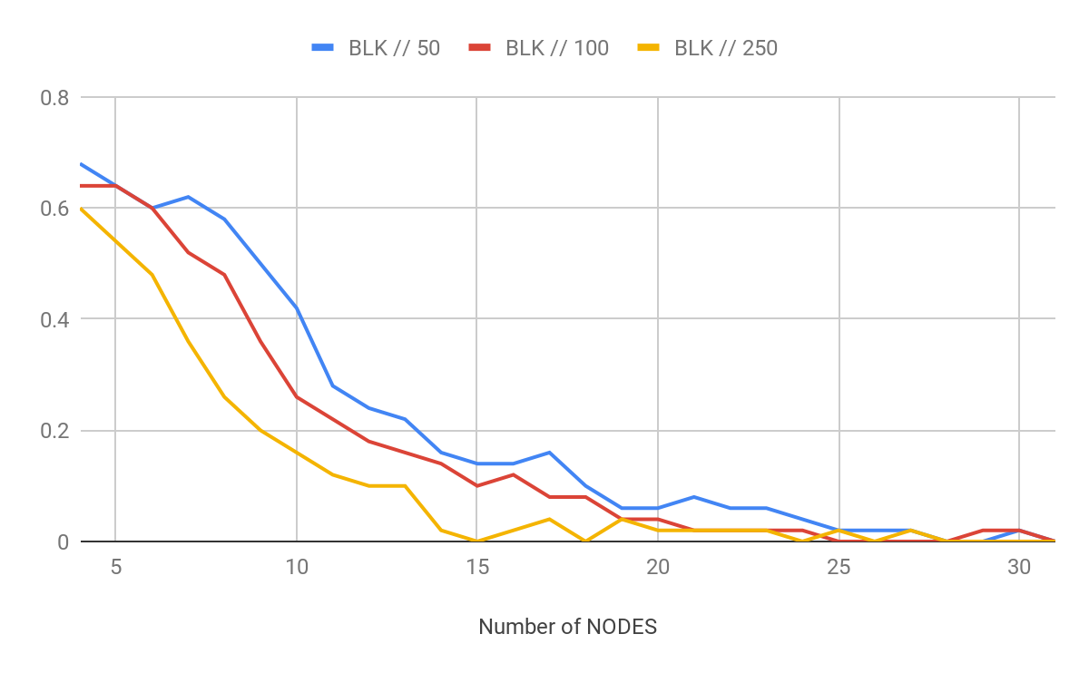
3. **TRANSACTION VS NODE : Large Transaction Size ( >=500 bytes) || Rest parameter - [** *Rate of transection : 1000 txn/sec Time duration : 50 sec* **]**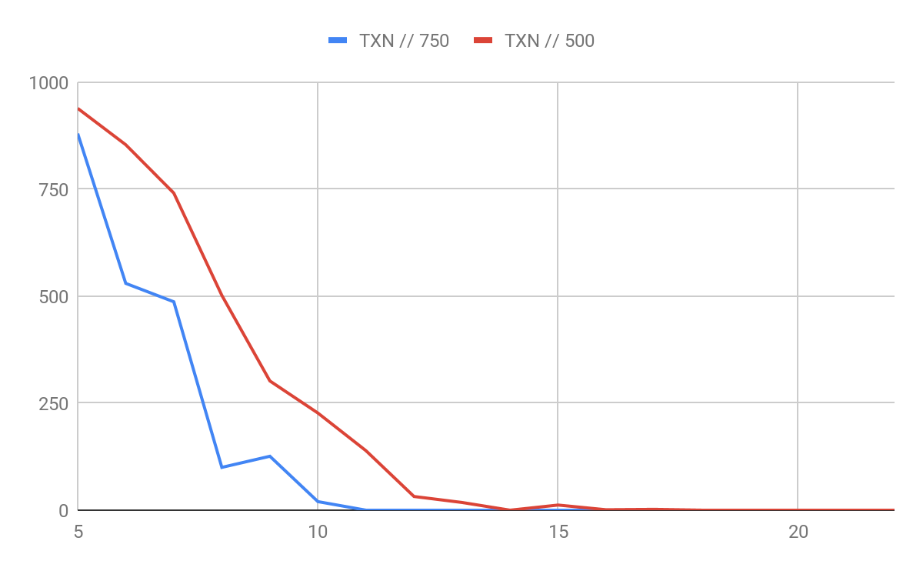

**ANALYSIS-** These Peaks in the graph are due to failed synchronous Tendermint Network, If the number of Validator or Transaction size is bigger. This leads to longer dialing up for peer by the tendermint node. If was tm -bench runs for that interval, the network results in no transaction processing.

1. **BLOCKS/SEC VS NODE : Large Transaction Size ( >=500 bytes) || Rest parameter - [** *Rate of transection : 1000 txn/sec Time duration : 50 sec* **]**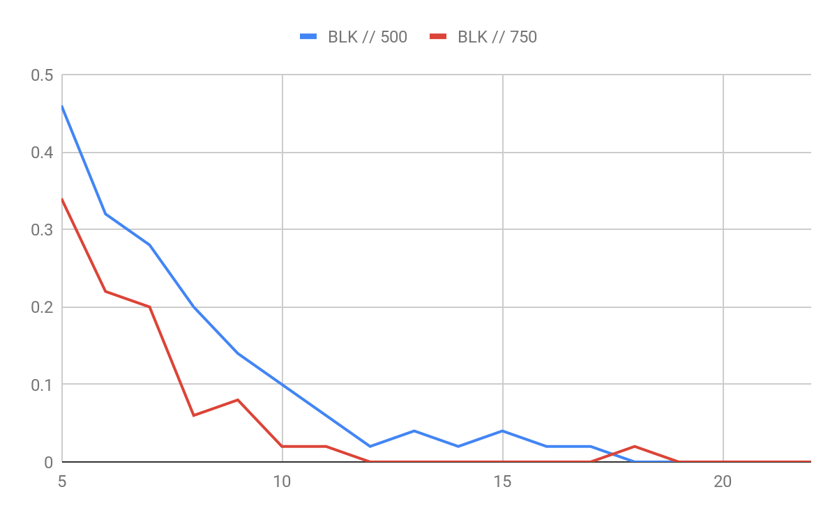

## THROUGHPUT DATA *[Varying Transaction Rate]*

1. **TRANSACTION/SEC VS NODE : Node - 5 || Rest parameter - [** *Rate of transection : variable Time duration : 50 sec* **]**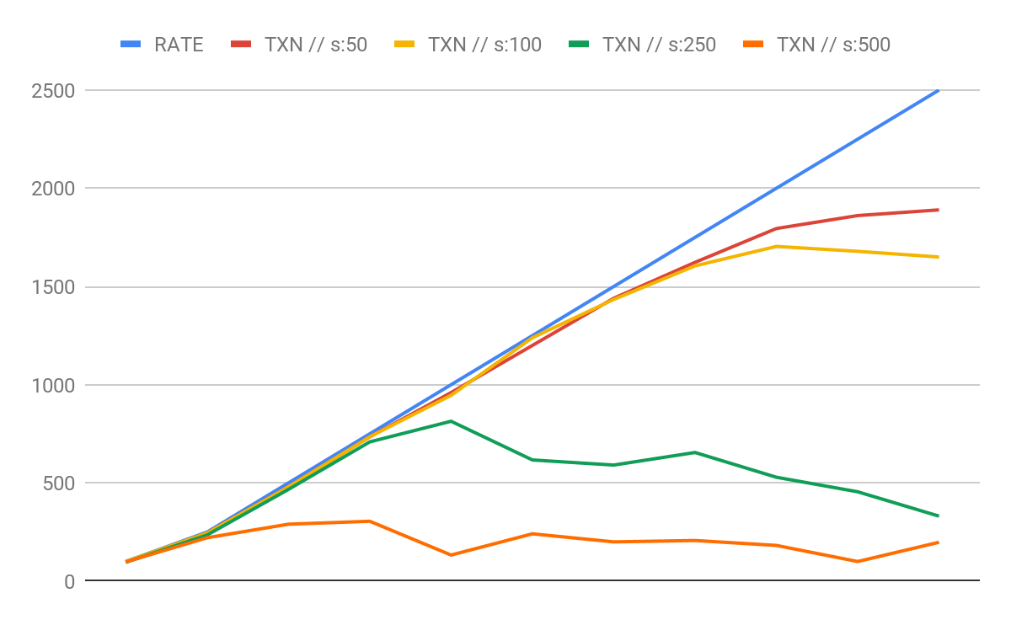
2. **BLOCK/SEC VS NODE : Node - 5 || Rest parameter - [** *Rate of transection : variable, Time duration : 50 sec* **]**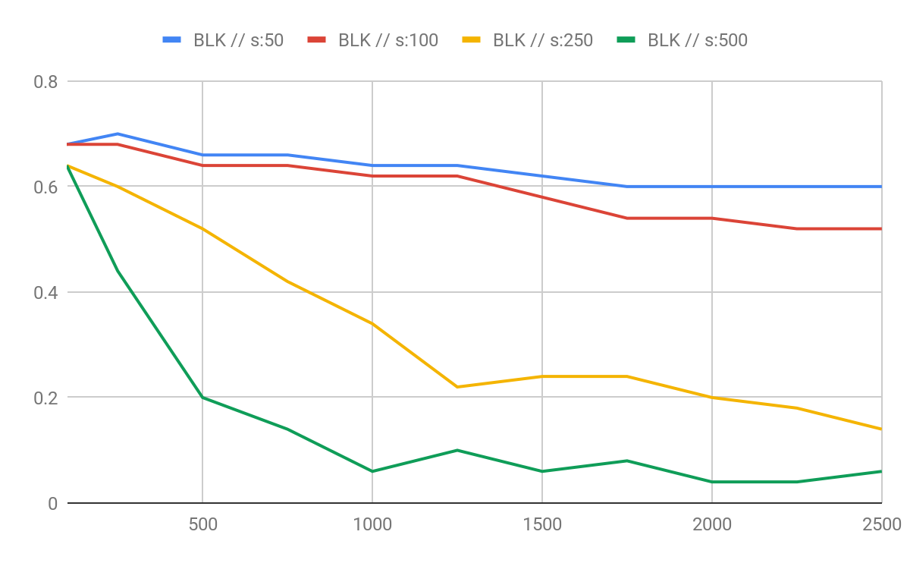

# MEMORY DATA *[Varying Transaction Size]*

1. **Memory Usage Percentage Vs Time** : Small Number of Node( =5 Node) || Rest parameter - [ *Rate of transaction : 1000 txn/sec Time duration : 200 sec* ]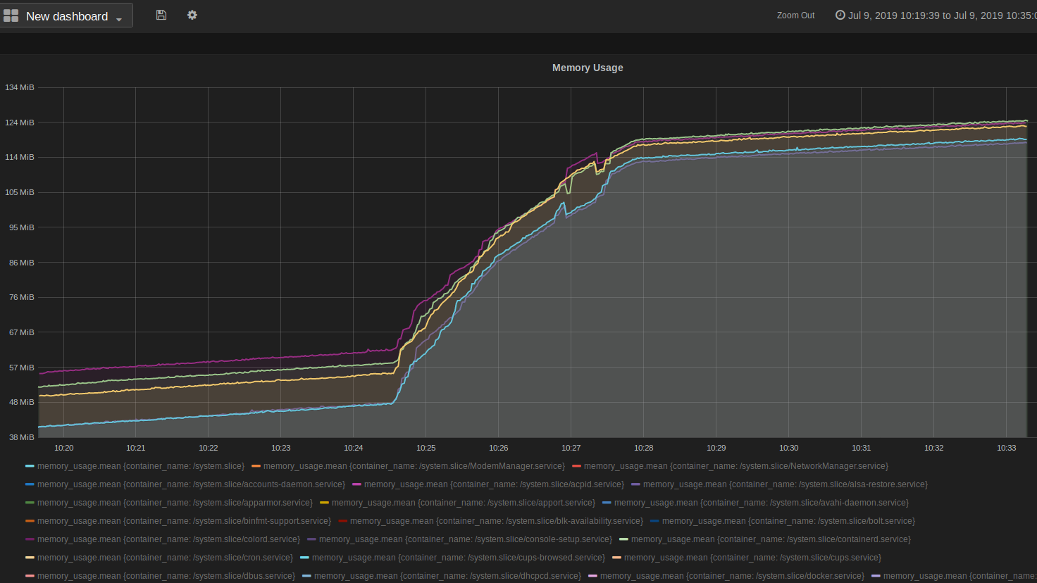
2. **Memory Usage Percentage Vs Time** : Number of Node( =5 Node) || Rest parameter - [ *Rate of transection : 1000 txn/sec Time duration : 300 sec* ]

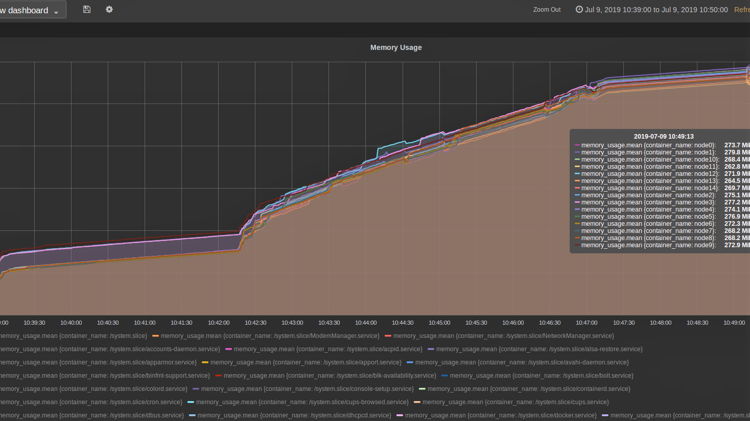

# CONCLUSION

After Testing tendermint on various parameter, the result shows that tendermint has a limit of 30 Nodes, after adding more node on top of it results in P2P Network breakdown. Also if I increase benchmarking and “peer dialup timeout” time then it shows a little transaction getting passed the consensus. When it comes to throughput, on increasing number of nodes, throughput decrease exponentially, and Increasing transaction size it gets more and more steeper.

But still for smaller number of validators, tendermint has relative high throughput compared to other consensus algorithm. Since it has a modular structure, it is good block-chain provider to run your own blockchain application on the top. It was also seen that it Tendermint core perform well in number of nodes upto 17 for any size of transaction size within 1000 Bytes.

When rate of transaction is increased the then lesser the transaction size better it gives the throughput. For the transaction size greater than 500 give poor throughput.